**DMIT 204 Application Programing 2 Project**

**Sales and Sales Return**

**By Pragnesh Patel**

**Wireframe for Sales**

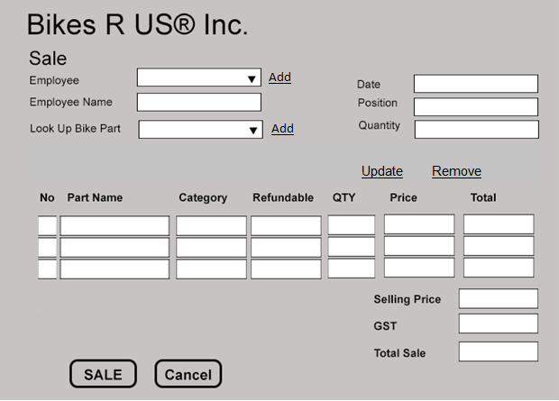

**LookupPart**

LookupPart will find the Bike parts information, passing by Integer PartNumebr or Varchar Description as argument and it will return Bike Parts Information.

**AddPartInfo**

System receive PartNumber as integer, quantity as integer and in response the part information will added to transaction list.

**UpdatePartInfo**

UpdatePartInfo will accept PartNumber as Integer and user can able to update selling Part, selling quantity and in response the part information will updated in transaction list.

**RemovePart**

Remove part will remove the added part in the system for selling using PartNumber as Integer. And in response system removes a bike part from the sales transaction list.

**Billing**

Billing will calculate the total selling including Taxes, Subtotal and Grand Total. Billing pass the partNumber, Subtotal, GrandTotal, Taxes and in response it will create sales number with all sales information.

**PaymentProcess**

In payment process we have three types 1) cash payment 2)Credit card 3) debit payment. The payment process receives SaleNumber as Integer and PaymentTypeCode as Integer and in response it will accept payment from customer.

**Wireframe for Sales Return**

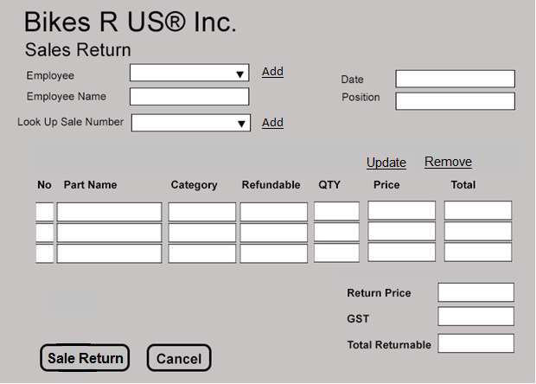

**LookupSaleInfo**

LookupSaleInfo recieves saleNumber as integer nd system will generat all the sales information as a response.

**AddSalesReturnPartInfo**

System will add parts information to the system to return parts and the arguments are PartNumber as integer, quantity as integer (want to return).

**UpdateSalesReturnPartInfo**

System will receive PartNumber as integer and in response thepart information will be updated in sales Return transaction list..

**RemoveSalesReturnPartInfo**

System will receive PartNumber as integer and in response the part information will remove from the sales return transaction list.

**SalesReturn**

SalesReturn will calculate the total returnable parts including Taxes, Subtotal and Grand Total. Passing by SalesNumber, PartNumber, SubTotal, GrandTota, Taxes. And in response sales return number will generate and make the sales return transaction list.

**RetunrProcess**

In return process we have three types 1) cash payment 2)Credit card 3) debit return. Return Process recieves SaleNumber as Integer and Total as Intger and response with return the money to the customer.